**Open React Folder:**

Open **cmd** where u want to create ur working folder like the following screanshot:

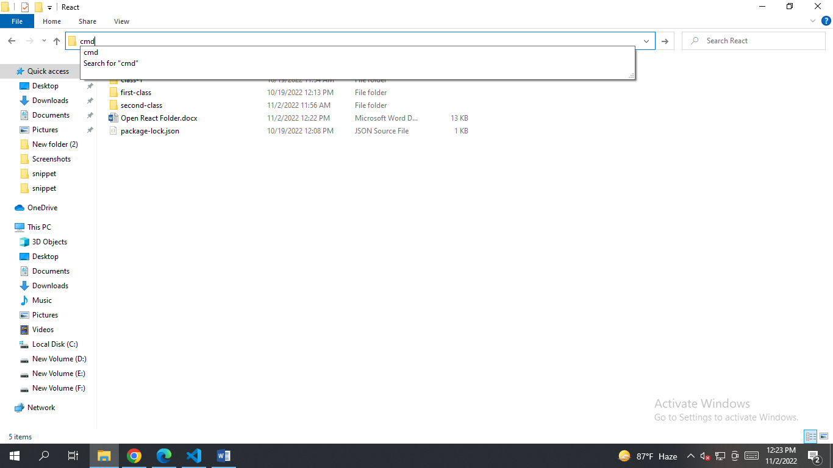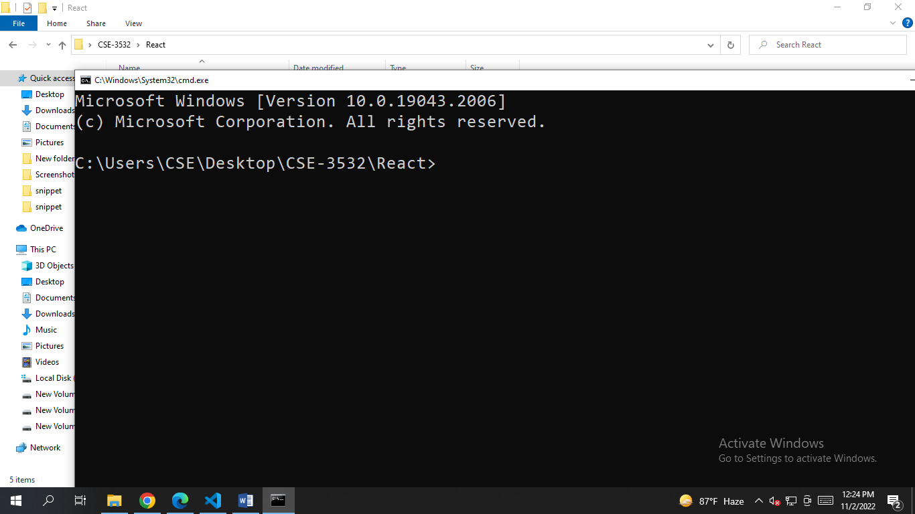

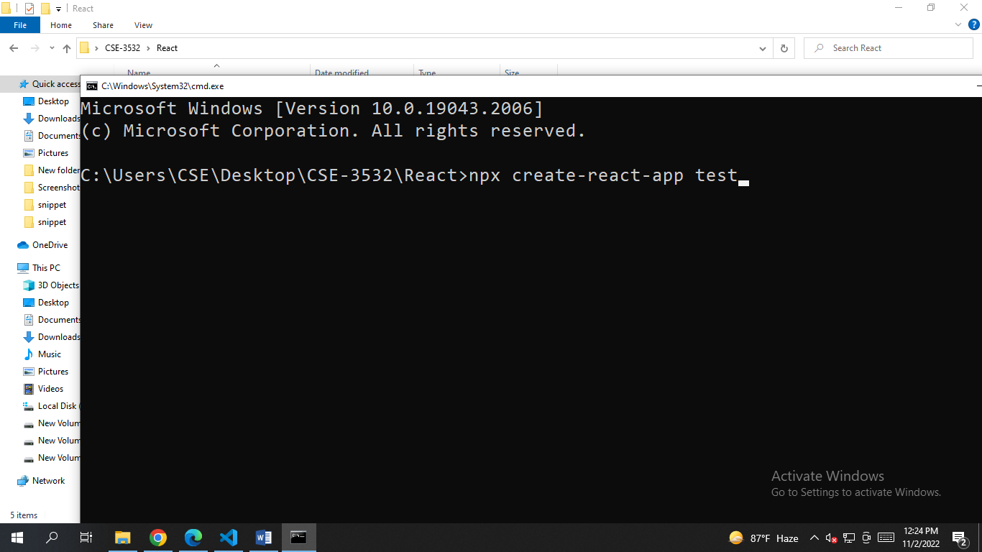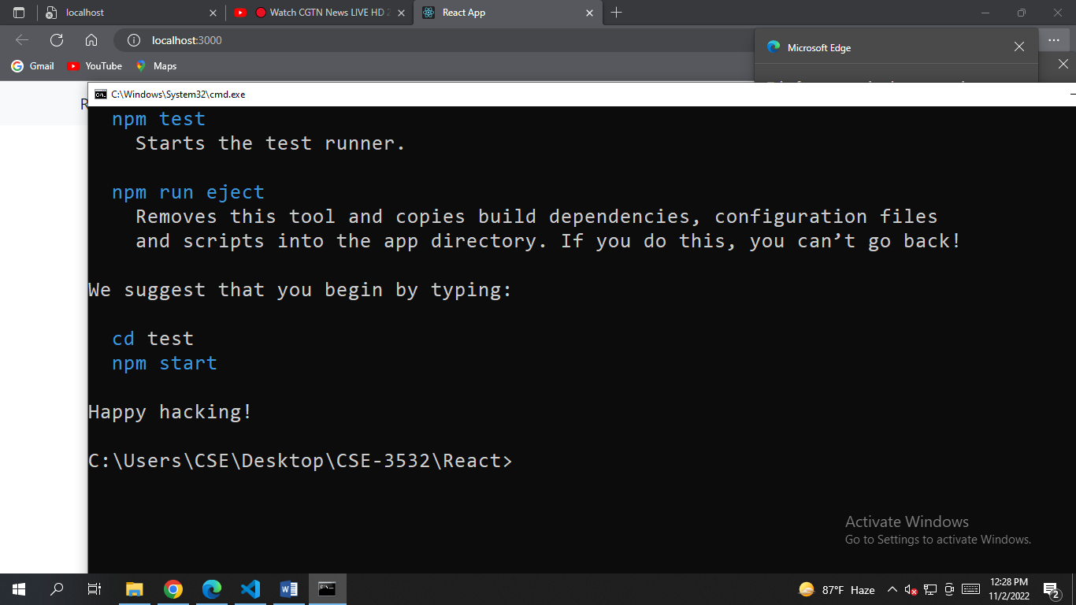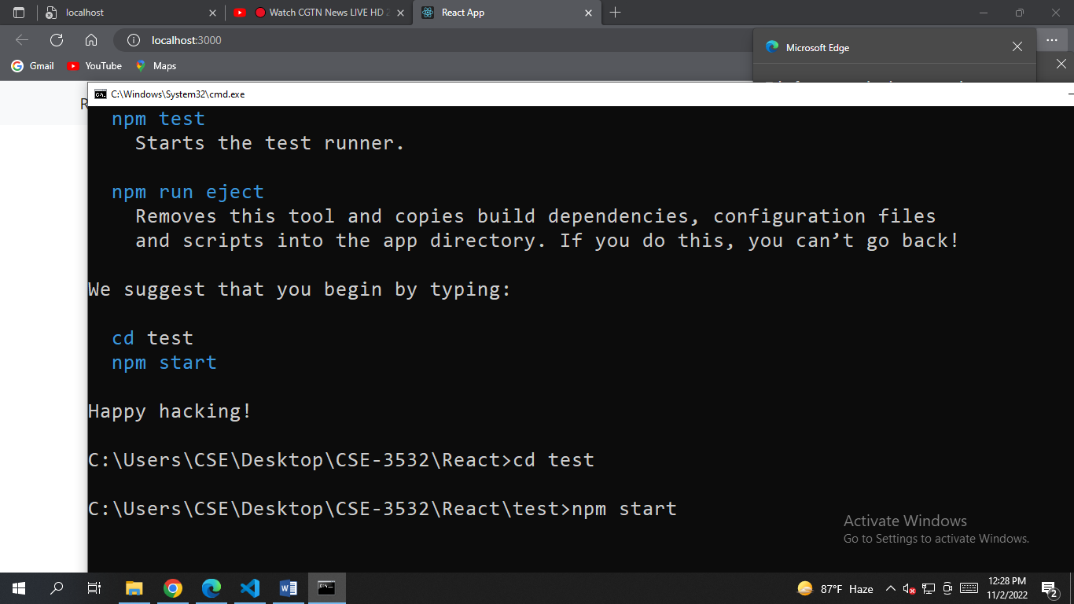

npx create-react-app *ur_app_name*

Then U have to wait sometimes depending on ur net connection

**Create a folder named “Components”**

**Components Name 1st Letter Must Be Capital!**

Install React router: Copy the **npm** link from <https://reactrouter.com/en/v6.3.0/getting-started/installation#basic-installation>

Install React Bootstrap: copy the css link from <https://react-bootstrap.github.io/getting-started/introduction/>